**Quarterly Report – Public Page**

**Date of Report:** *7th Quarterly Report, June 28, 2024*

**Contract Number:** *693JK32210001POTA*

**Prepared for:** *Government Agency: DOT and Co-funders*

**Project Title:** *Developing Corrosion Control Monitoring Technology for Hazardous Liquid Breakout Tanks*

**Prepared by:** *Pipeline Research Council International, Inc.*

**Contact Information:**  *Janie Norton,* [*jnorton@prci.org*](mailto:jnorton@prci.org) *703-205-1600 ext: 105*

**For quarterly period ending:** *June 30, 2024*

**1: Items Completed During this Quarterly Period:**

|  |  |  |  |  |  |
| --- | --- | --- | --- | --- | --- |
| ***Item***  ***#*** | ***Task***  ***#*** | ***Activity/Deliverable*** | ***Title*** | ***Federal Cost*** | ***Cost Share*** |
| 16 | 4 | Collection of the laboratory experimental data, control experiment data, and retrieval of the coupons, ER probes, and UT-based mass-loss coupons | Summary of the data retrieved from various testing included in the quarterly report | $34,722 | $34,722 |
| 20 | 2 | Analysis of the monitoring data to determine the inspection intervals | Results to be included in the quarterly report | $3,258 | $3,258 |
| 21 | 5 | Quarterly Project Management & Status Update Reporting | Submit 7th quarterly report | $4,477 | $4,477 |

**2: Items Not Completed During this Quarterly Period:**

|  |  |  |  |  |  |
| --- | --- | --- | --- | --- | --- |
| ***Item***  ***#*** | ***Task***  ***#*** | ***Activity/Deliverable*** | ***Title*** | ***Federal Cost*** | ***Cost Share*** |
| 18 | 2 | Analyze various monitoring data to determine the direct and indirect corrosion rates and compare those to the tank bottom indications, and regulatory requirements | Results to be included in the quarterly report | $9,121 | $9,121 |
| 19 | 4 | Analysis of the laboratory scale experimental data, and the control experiments data | Results to be included in the quarterly report | $3,258 | $3,258 |

**3: Project Financial Tracking During this Quarterly Period:**

Note that this chart reflects Federal share only.

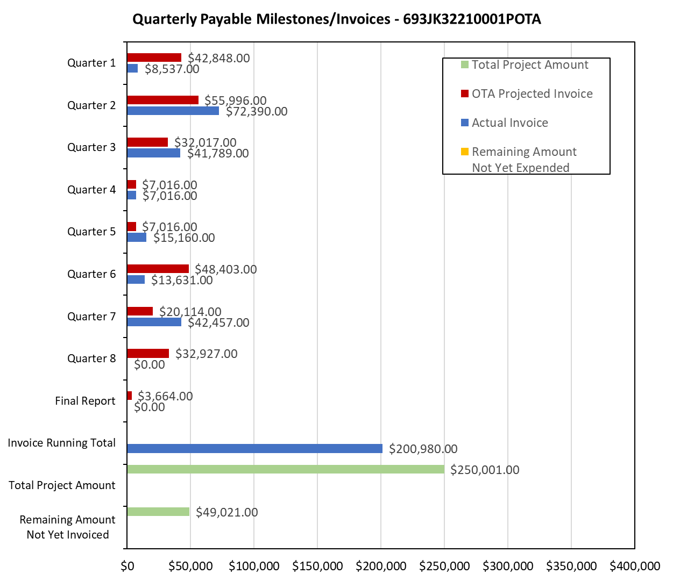

**4: Project Technical Status:**

**Item 16, Task 4 ⎯ Collection of the laboratory experimental data, control experiment data, and retrieval of the coupons, ER probes, and UT-based mass-loss coupons**. Summary of the data retrieved from various testing included in the quarterly report: The monitoring data from the laboratory experiments is available and has been analyzed. The monitoring data show that the effect of the VCI in the cone-up configuration is similar to the flat tank bed. Monitoring data from the control-part of the large-scale experiments, i.e., without VCI injection, are also available and has been analyzed. The monitoring data from the large-scale experiments showed steady corrosion on the ER probes. In addition, the coupons placed during the start of the large-scale experiments have been retrieved. The control-coupons were retrieved when VCIs were injected. In the first large-scale experiment, the coupons were retrieved during the first month of this quarter (7th). Similarly, the control coupons were also retrieved from the second large-scale experiments prior to VCI injection. The coupons have exhibited significant corrosion. This item broadly links to items 8 and 9 in Attachment 1 Team Project Activities. This item also links to item 8 in Attachment 2 Project Deliverables.

**Item 20, Task 2 ⎯ Analysis of the monitoring data to determine the inspection intervals.** Results to be included in the quarterly report: The monitoring data from three tanks were analyzed to estimate inspection interval as per API 653. The monitoring data were analyzed for three tanks: two tanks with indications of severe soil-side corrosion and one tank with minimal indication of soil-side corrosion. For the first two tanks with severe soil-side corrosion, the soil-side indications in the API 653 inspection reports had significant corrosion, and the targeted monitoring data at four locations also exhibited comparable corrosion. The tank inspection intervals were calculated using the monitoring data and were within the range of the pre-repair inspection intervals reported in API 653 reports of the respective tanks. For the third tank, the soil-side corrosion indications were not severe and the same was observed in the coupons that were placed under the tanks. For the third tank, the monitoring-based inspection intervals were also within the range of the values listed in the API 653 inspection report. The key take away: effective monitoring provides a reasonable estimate of the inspection interval. This item links to item 9(e) in Attachment 1 Team Project Activities. This item also links to item 9 in Attachment 2 Project Deliverables.

**Item 21, Task 5  Quarterly Project Management & Status Update Reporting.** Submit 7th quarterly report: The 7th quarter project meeting was held. This item has been completed. This item links to items 10 and 12 in Attachment 1 Team Project Activities. This item also links to item 10 in Attachment 2 Project Deliverables.

**5: Project Schedule:**

The project is behind schedule, and a 9-month no-cost extension request was submitted and approved.